Name

Mathematics Stage 5 Core
Surface Area of Prisms and Cylinders

Book 1 |  | Version: 261002  Feedback:  https://MrDingMaths.com
Contents
Syllabus Content 2
Learning Intention 3

Syllabus Content
MA5-ARE-C-01 solves problems involving the surface area of right prisms and practical problems involving the area of composite shapes and solids
Solve problems involving areas and surface areas
- Solve practical problems involving the areas of composite shapes
- Identify the edge lengths and the faces making up the surface area of prisms
- Recognise and justify whether a diagram represents a net of a right prism
- Create and rearrange nets of right prisms
- Find the surface areas of prisms, given their nets, excluding curved surfaces
- Solve problems involving surface areas of prisms, excluding curved surfaces
Develop and apply the formula for surface areas of cylinders
- Recognise the curved surface of a cylinder as a rectangle and apply this knowledge to calculate the area of the curved surface
- Develop and apply the formula to find the surface area of a closed cylinder: $A=2{πr}^{2}+2πrh,$ where $r$ is the length of the radius and $h$ is the perpendicular height
Solve problems involving surface areas of cylinders and related composite solids
- Solve problems involving surface areas of cylinders and related composite solids

Nets of 3D solids

- Nets
A net shows a 3D shape’s faces laid flat.
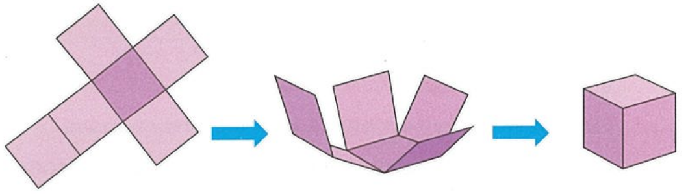
A prism has two identical faces connected by rectangles.

- Identify nets of right prisms
Name the prism that is made from each net.
https://mathigon.org/polypad/Qrx1t9V9RTSqA
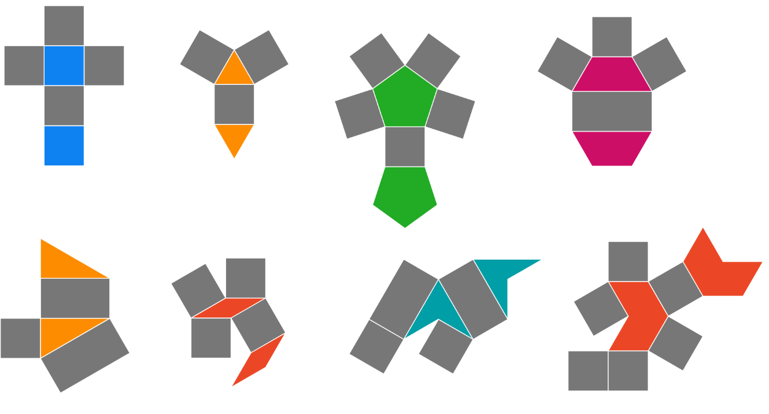

Foundation
- Give the name of each of the 3-D shapes that can be made from these nets.
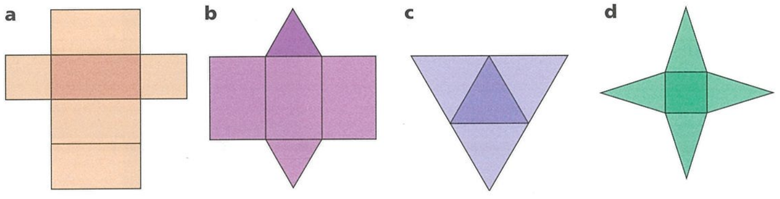  Rectangular prism | Trianglular prism | 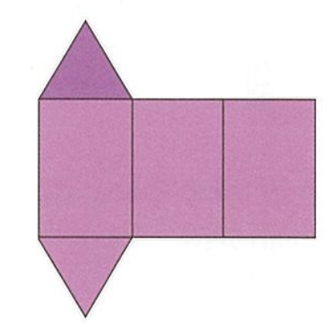  Triangular prism

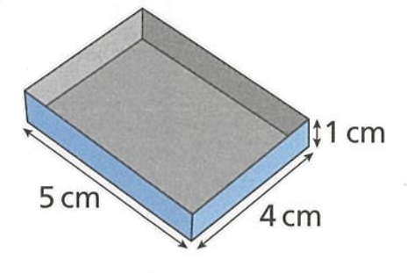
- Sketch an accurate net for this open box.

- Sketch a net for each of these shapes.
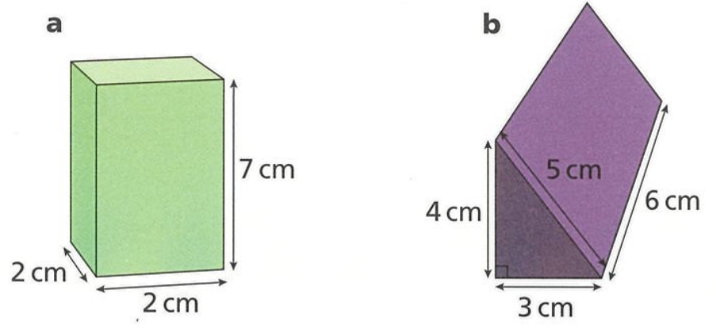

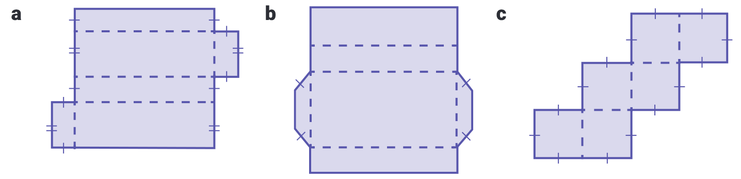
- Name the solid made by the net.
Rectangular prism | Cube | 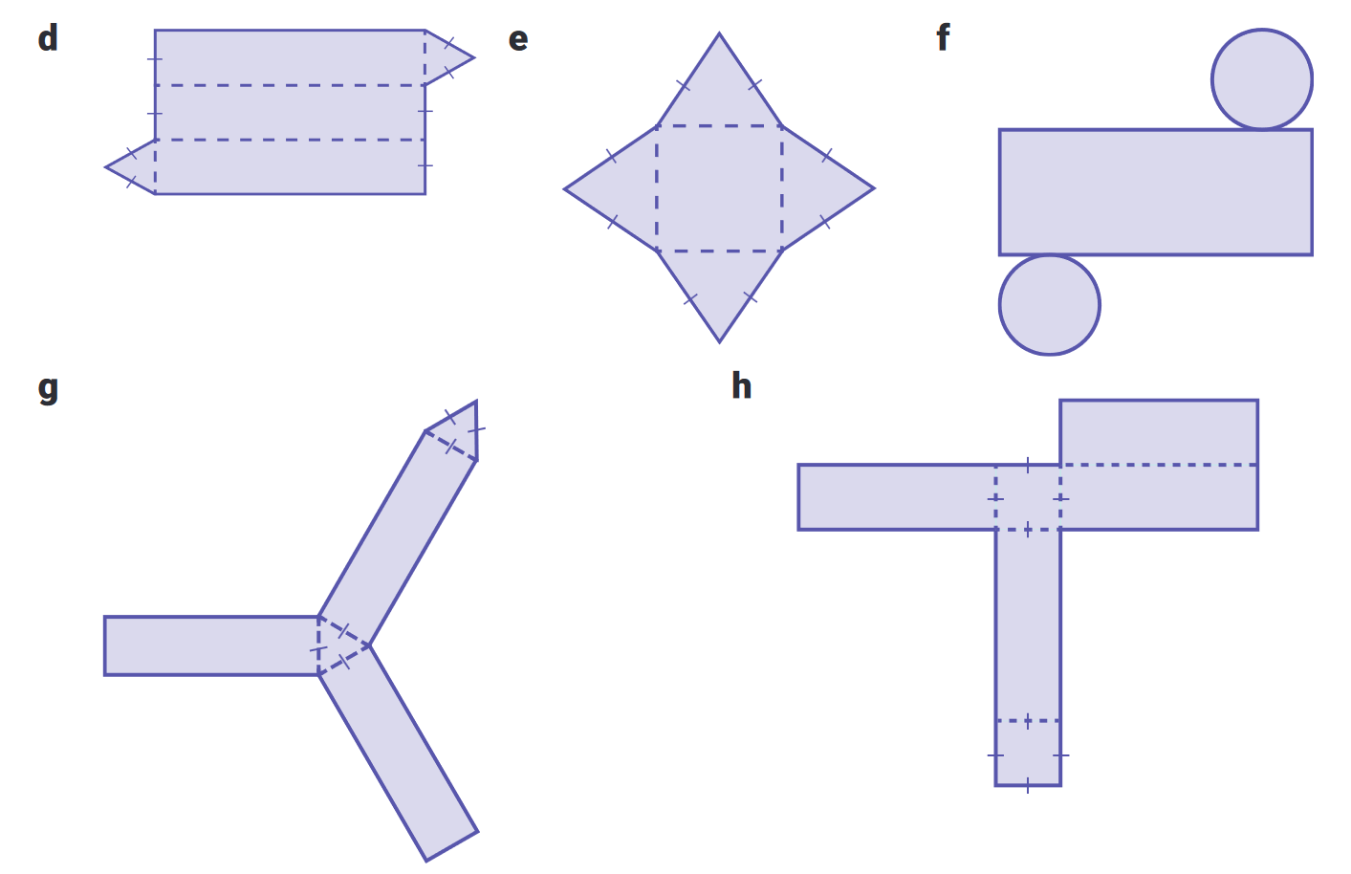  Triangular prism
Cylinder | Square prism | Trapezoidal prism

Surface Area

- Surface Area
The surface area of a prism is the total area of all its faces.
It equals the area of the prism's net.
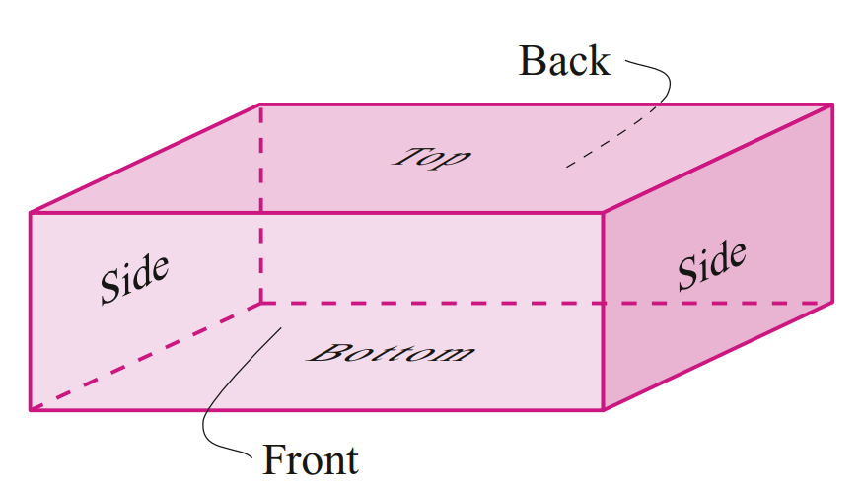

- Example Calculate surface area of prisms given their nets
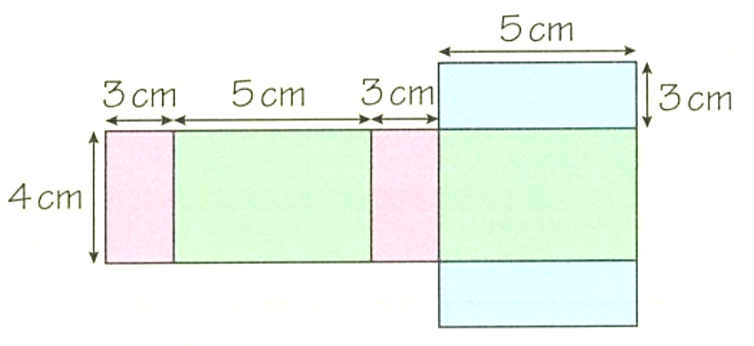
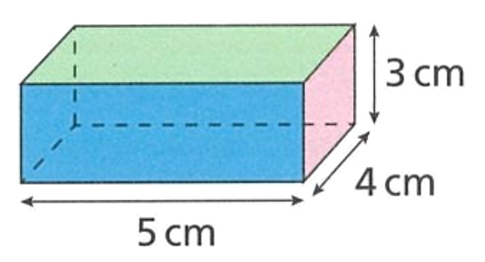

Area of front and back: $\left(5×3\right)×2=30$  Area of sides: $\left(4×3\right)×2=24$  Area of bottom and top: $\left(5×4\right)×2=40$ | Total surface area: $30+24+40$  $=94 {cm}^{2}$

- Guided Practice
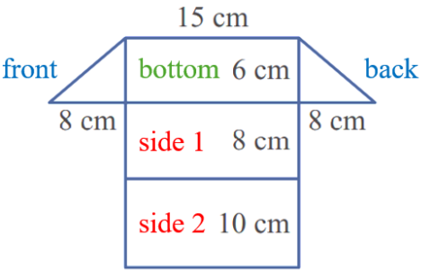
Calculate the surface area
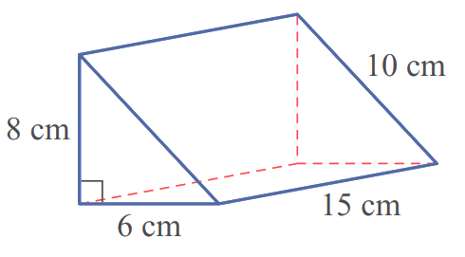

Area of front and back:  Area of side 1:  Area of side 2:  Area of bottom: | Total surface area:  408 cm²

- Key Ideas
- The ………………… ……………… of a prism is the area of the outer parts of the solid.
It can be calculated by adding up the areas of all of the …………………………

Foundation
- Find the surface area.
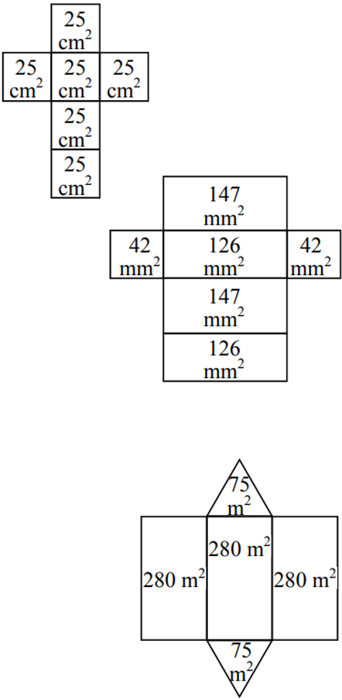  150 cm² | 630 mm² | 990 m²

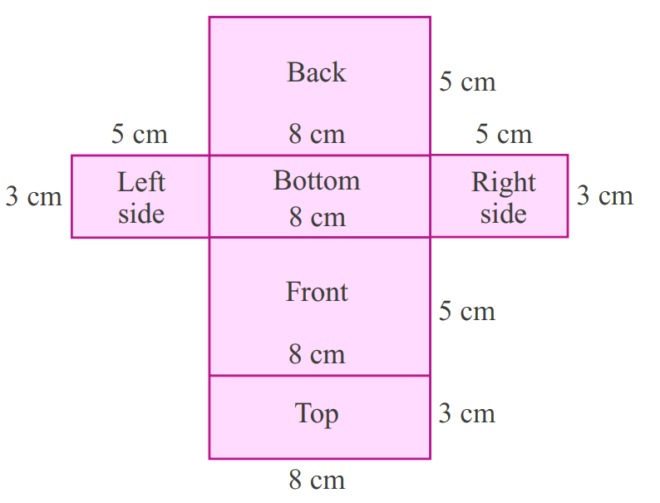
- Calculate the surface area of these prisms.
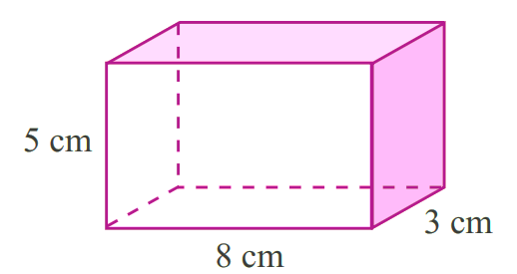

Area of front and back: ……………………  $$\left(5×8\right)×2$$  Area of sides: ……………………  $$\left(3×5\right)×2$$  Area of bottom and top: ……………………  $$\left(3×8\right)×2$$ | Total surface area: ……………………  $=$ ……………………  158 cm²
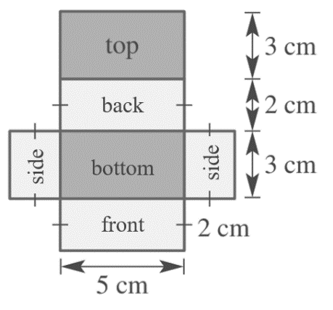
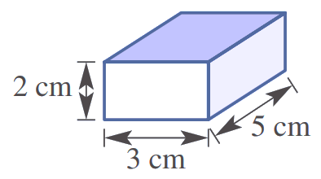

Area of front and back: ……………………  $$(3×2)×2$$  Area of sides: ……………………  $$(5×2)×2$$  Area of bottom and top: ……………………  $$(3×5)×2$$ | Total surface area: ……………………  $=$ ……………………  $62$ cm²

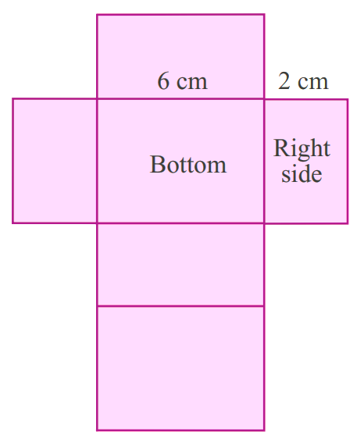
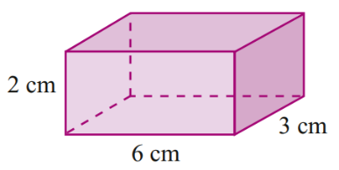

Area of front and back: ……………………  $$(6×2)×2$$  Area of sides: ……………………  $$(3×2)×2$$  Area of bottom and top: ……………………  $$(6×3)×2$$ | Total surface area: ……………………  $=$ ……………………  $72$ cm²
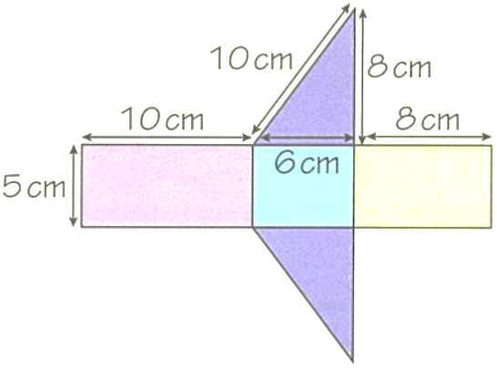
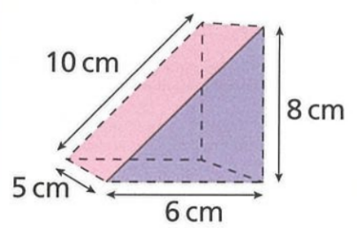

Area of front and back: ……………………  $$\left(\frac{6×2}{2}\right)×2$$  Area of left side: ……………………  $$5×10$$  Area of right side: ……………………  $$5×8$$  Area of bottom: ……………………  $$6×5$$ | Total surface area: ……………………  $=$ ……………………  132 cm²

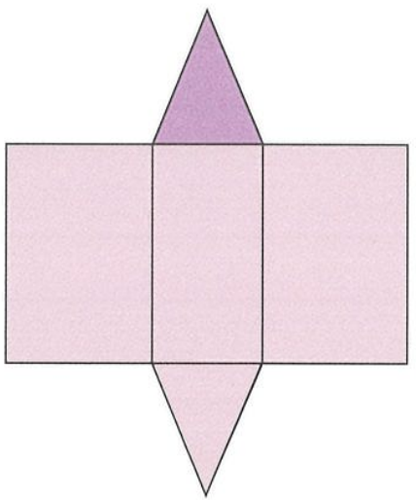
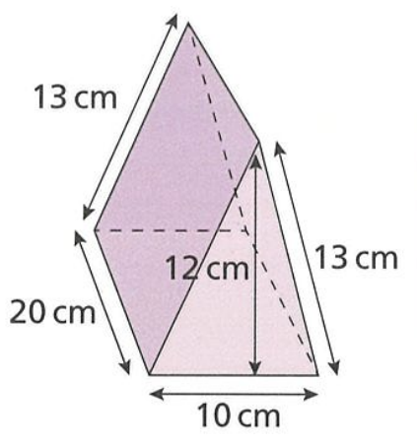

Area of front and back: ……………………  $$\left(\frac{10×12}{2}\right)×2$$  Area of left side: ……………………  $$20×13$$  Area of right side: ……………………  $$20×13$$  Area of bottom: ……………………  $$10×20$$ | Total surface area: ……………………  $=$ ……………………  840 cm²

Surface Area of a Rectangular Prism without a Net

- Surface Area
To find surface area, picture the faces covering the 3D shape.
This avoids having to draw out the net.

- Example Calculate surface area of a rectangular prism without a net
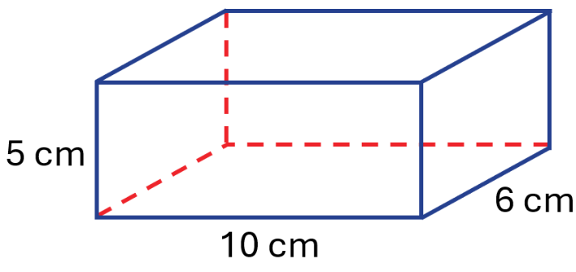

front and back rectangles | 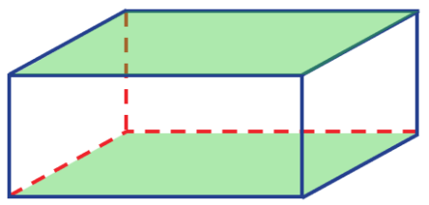  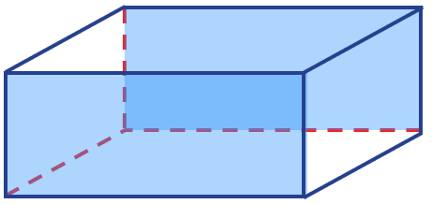  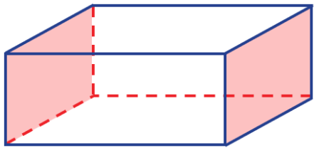  side rectangles | top and bottom rectangles
$\left(10×5\right)×2$  $=100$ | $\left(5×6\right)×2$  $=60$ | $\left(10×6\right)×2$  $=120$
Total surface area $=100+60+120$
$=280 cm^{2}$

- Guided Practice
Calculate the surface area of this rectangular prism.
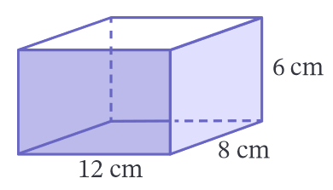

front and back | side | top and bottom
Total surface area:

432 cm²

Foundation
- Find the surface area of these solids.
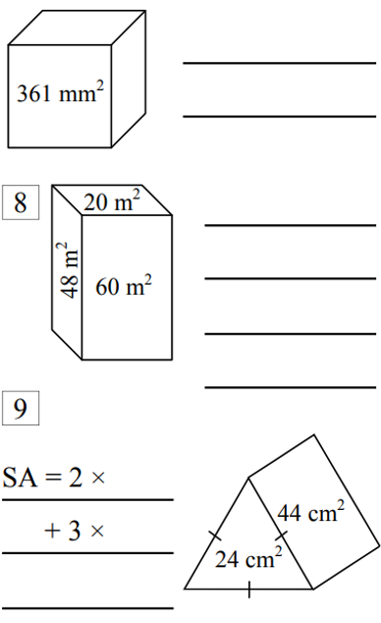  Area of front and back  $$60×2$$  Area of sides  $$48×2$$  Area of top and bottom  $$20×2$$  Total surface area  $256$ m² | $2166$ m² | 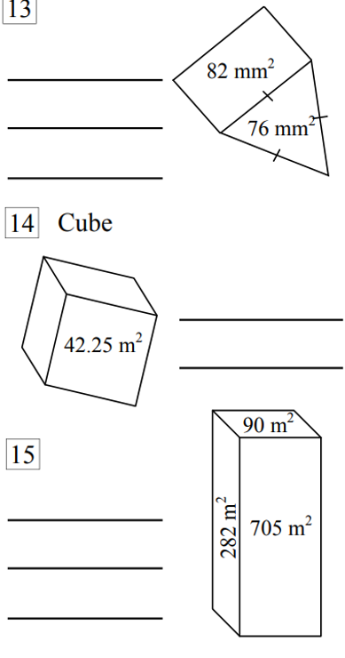  $253.5$ m²

- Complete the following the calculate the surface area of the rectangular prism.
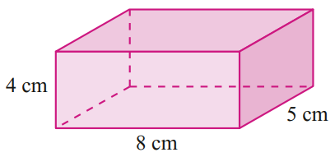
Area of front and back = (8 × ……) × 2 = ………cm²
$$\left(8×4\right)×2$$
Area of both sides = (…… × ……) × 2 = ……… cm²
$$\left(5×4\right)×2$$
Area of top and bottom = (…… × ……) × 2 = ……… cm²
$$\left(8×5\right)×2$$
Total surface area = …… + …… + …… = ……… cm²
184 cm²
- Find the surface area of the following prisms.
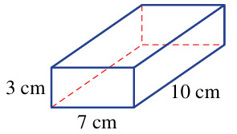  Front and back:  $$\left(7×3\right)×2$$  Sides:  $$\left(3×10\right)×2$$  Top and bottom:  $$\left(7×10\right)×2$$  Total surface area  242 cm² | 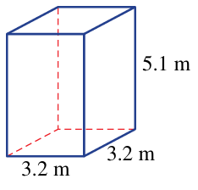  Front and back:  $$\left(3.2×5.1\right)×2$$  Sides:  $$\left(3.2×5.1\right)×2$$  Top and bottom:  $$\left(3.2×3.2\right)×2$$  Total surface area:  $85.76$ m²

Development
- Find the surface area of the following prisms.
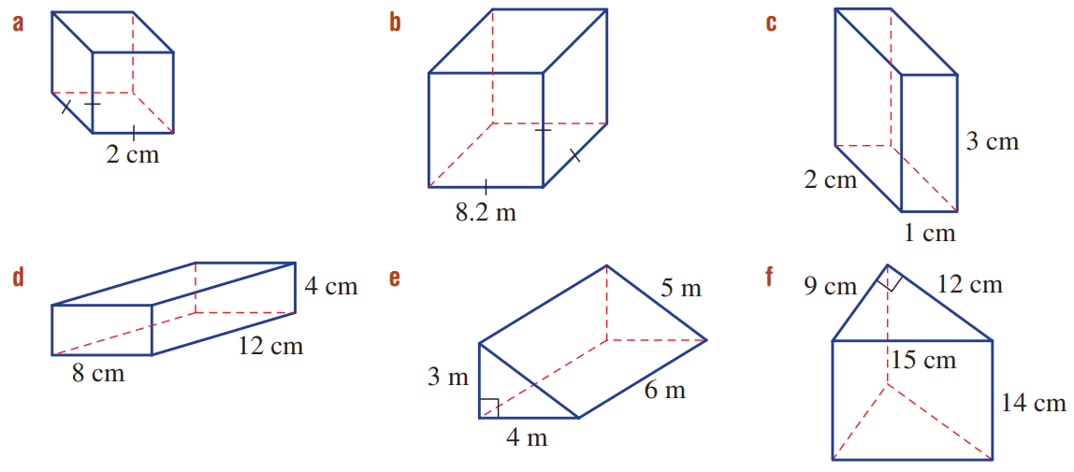  $403.4$ cm² | $22$ cm²

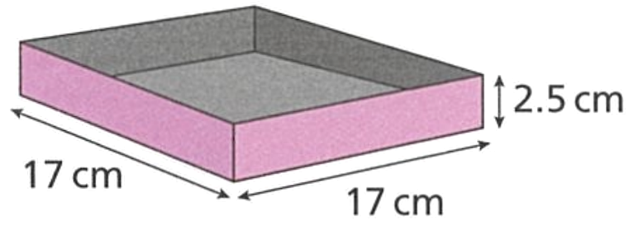
- Beca makes an open box. She is going to paint the outside of the box.
Work out the total area to be painted.

459 cm²
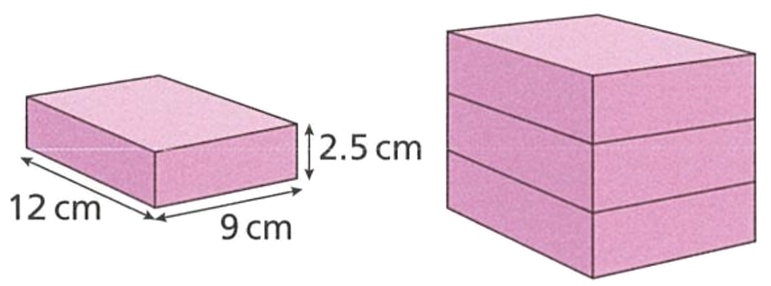
- Ed stacks three identical rectangular prisms on top of each other as shown.

He says “The surface area of my shape will be three times as large as the surface area of one of the rectangular prisms.”
Explain why he is wrong.

When you stack the prisms, two faces are no longer on the surface, so the surface area will be less.
- A book measuring 20 cm long, 15 cm wide and 3 cm thick is covered in plastic.
What area of plastic is needed to cover 1000 books? Convert your answer to m².

SA of 1 book: 810 cm²
SA of 1000 books: 810 000 cm² ÷ 100² = 81 m²

Mastery
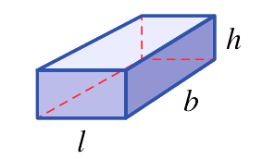
- Consider the rectangular prism shown.

  - Write an expression for the surface area of the prism.

$$SA=2lb+2lh+2bh$$
  - By factorising, show that the formula for the surface area for any rectangular prism is $SA=2\left(lb+lh+bh\right)$.

Factorise out common factor of 2 from expression in part a.
- Use this formula to quickly calculate the surface area of these rectangular prisms.
- Surface Area of a Rectangular Prism
$SA=2\left(lb+lh+bh\right)$

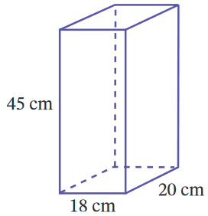  4140 cm² | 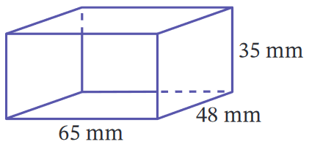  14 150 mm² | 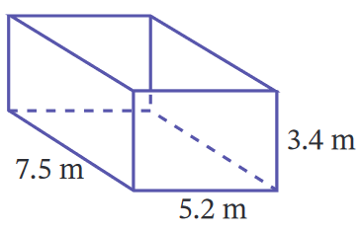  164.36 m²

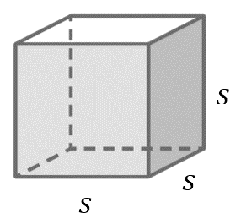
- What would be the formula for the surface area of a cube with side length $s$?

$$6s^{2}$$
- A rectangular prism storage crate measures 0.8 m by 1 m by 1.5 m.
Claudia paints all the faces of the crate.
One tin of paint costs $8. Each tin covers 4 m²
Work out the total cost of the paint that Claudia needs.

Surface area = 7 m²
2 paint tins needed
$$\$8×2=\$1$$
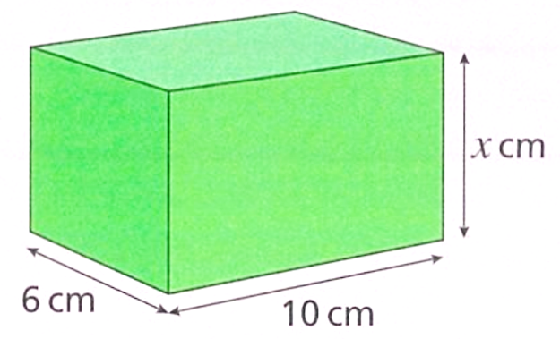
- The surface area of this rectangular prism is 376 cm². Work out the value of $x$.

$$376=2\left(60+6x+10x\right)$$
$$188=60+16x$$
$x=8$ cm
Work out the value of $x$ in each of these rectangular prisms.
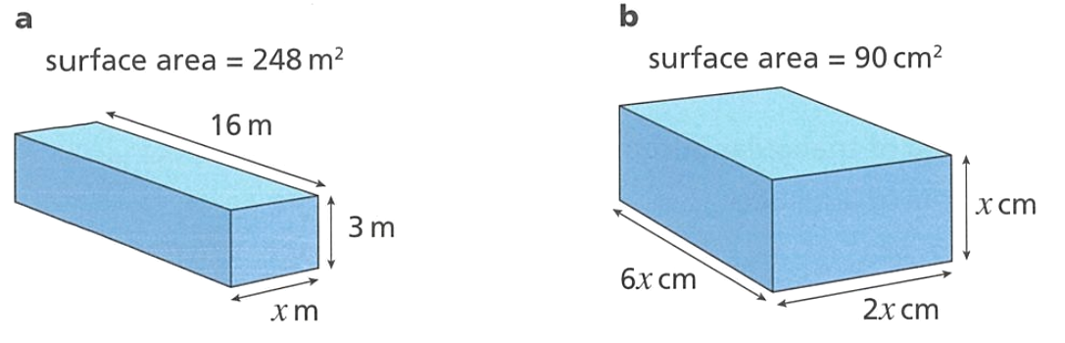  $4$ m | $1.5$ cm

- A cube has surface area 150 m². Determine the length of each side of the cube.

$$150=6x^{2}$$
$$x^{2}=25$$
$x=5$ m

- NAPLAN A+
The rectangular prism, shown below, is cut in half to form 2 equal cubes.
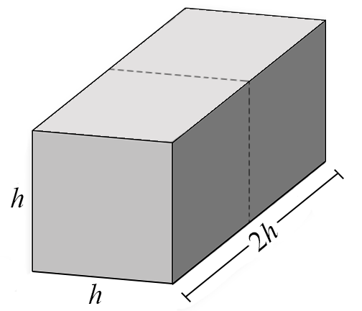
What is the ratio of the surface area of the rectangular prism to one of the cubes?

SA of 1 cube = $6h^{2}$
SA of prism = $2\left(h^{2}+2h^{2}+2h^{2}\right)=10h^{2}$
Ratio of prism to cube = $10h^{2}:6h^{2}$
$$=5:3$$
- A rectangular prism has dimensions in the ratio 1:3:5. It has a volume of 120 cm³. Find:
  - the dimensions of the prism.

Let sides be $x, 3x,5x$
$$V=Ah$$
$$120=15x^{3}$$
$$x=2$$
Dimensions are 2 cm, 6 cm, 10 cm
  - the surface area of the prism.

$$SA=2\left(2×6+2×10+6×10\right)$$
$=184$ cm²

Surface Area of a Triangular Prism without a Net

- Example Calculate surface area of a triangular prism without a net
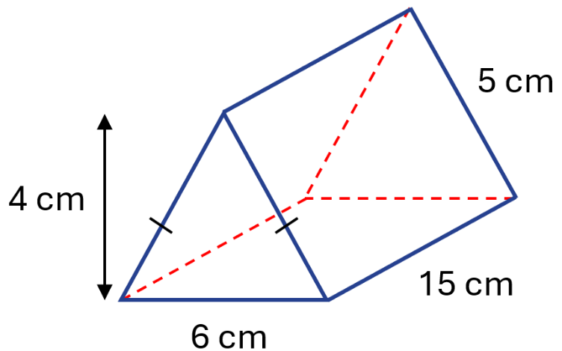

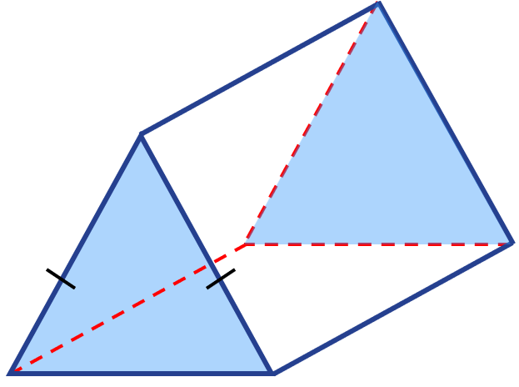  front and back triangles | 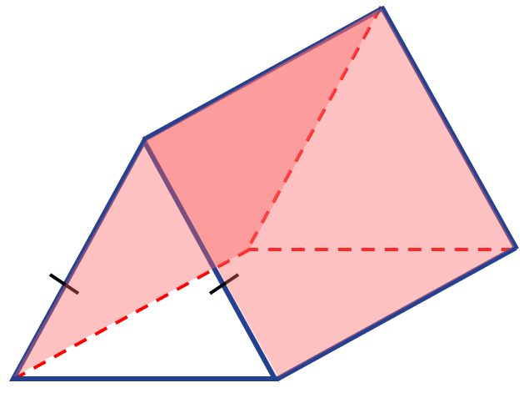  side rectangles | 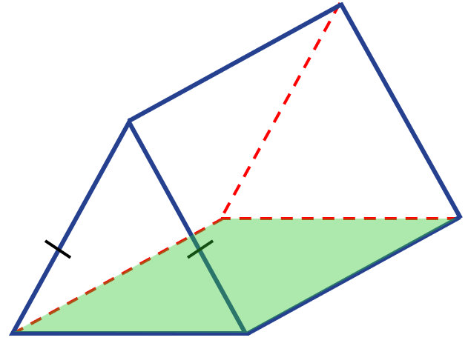  bottom rectangle
$\left(\frac{6×4}{2}\right)$ $×2$  $=24$ | $\left(15×5\right)×2$  $=150$ | $6×15$  $=90$
Total surface area $=24+150+90$
$=264 cm^{2}$

- Guided Practice
Calculate the surface area of this triangular prism.
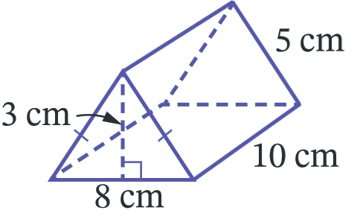

front and back triangles | side rectangles | bottom rectangle
Total surface area:

204 cm²

Foundation
- Calculate the surface area of these triangular prisms.
398 mm² | 180 cm²

- Calculate the surface area of these triangular prisms.
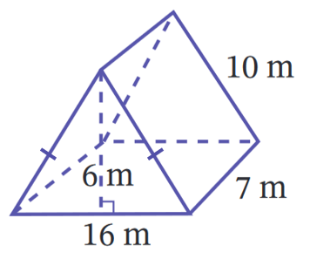  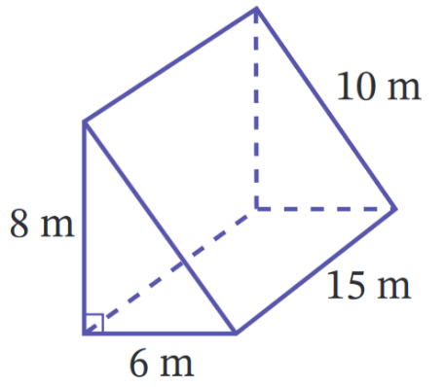  Area of front and back: ……………………  $$\left(\frac{16×6}{2}\right)×2$$  Area of sides: ……………………  $$7×10$$  Area of bottom: ……………………  $$7×16$$  Total surface area: ……………………  348 cm² | Area of front and back: ……………………  $$\left(\frac{6×8}{2}\right)×2$$  Area of left side: ……………………  $$15×8$$  Area of right side: ……………………  $$15×10$$  Area of bottom: ……………………  $$15×6$$  Total surface area: ……………………  408 cm²
84 m² | 612 cm²

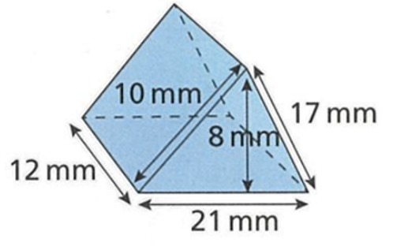
- Find the surface area of the triangular prism.

744 mm²

Development
- Calculate the missing length using Pythagoras’ Theorem, then calculate the surface area.
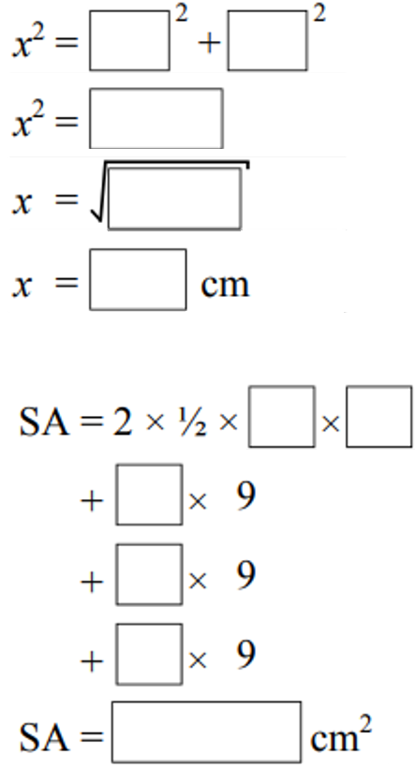
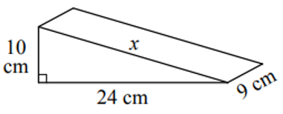

$x=26$ cm, $SA=780$ cm²
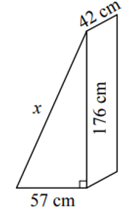  $x=185$ cm, $SA=$ 27 588 cm² | 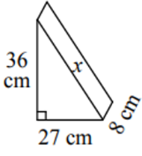  $x=45$ cm, $SA=$ 1836 cm²

For these triangles, you are finding a shorter side, not the hypotenuse.
Calculate the surface area.
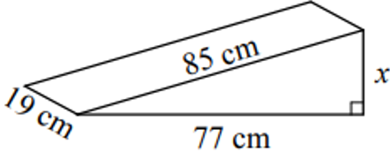  $x=36$ cm, $SA=$ 6534 cm² | 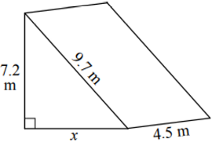  $x=6.5$ cm, $SA=$ 152.1 m²
Halve the base, then find the missing length.
Calculate the surface area.
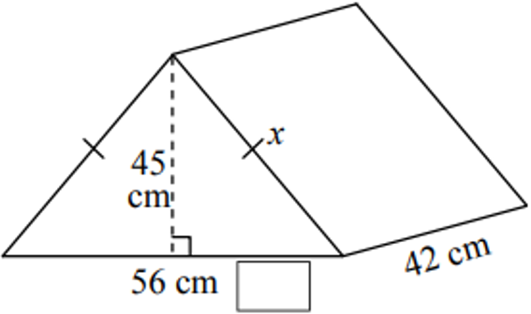  $x=53$ cm, $SA=$ 9324 cm² | 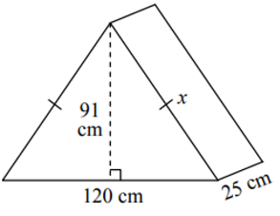  $x=109$ cm, $SA=$ 19 370 cm²
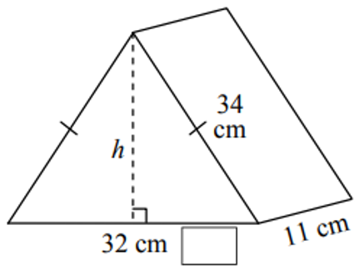  $h=$ 30 cm, $SA$ = 2060 cm² | 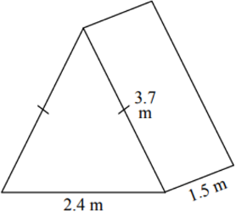  $h=$ 3.5 m, $SA=$ 23.1 m²
- Use Pythagoras’ Theorem $h^{2}=a^{2}+b^{2}$ to find unknown lengths and hence calculate the surface area of these solids. Round to 1 d.p. where necessary.
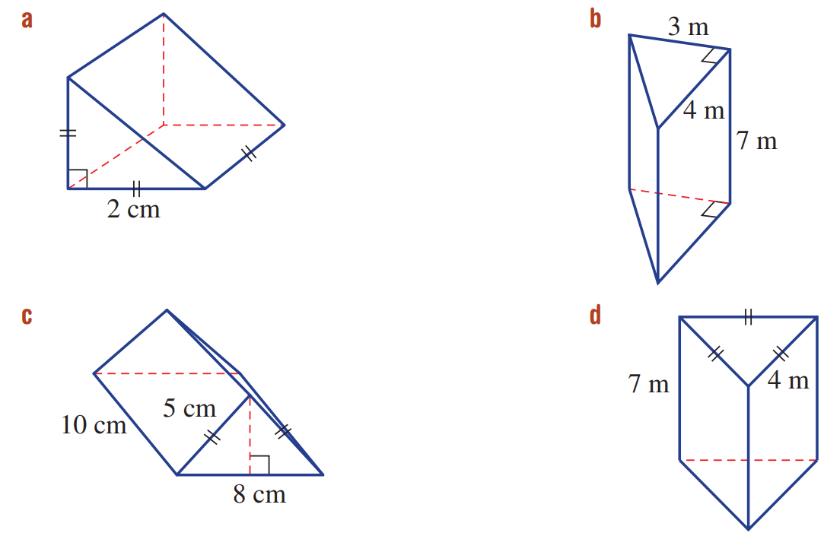  96 m² | - All units in cm.  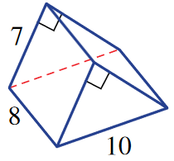  243.1 cm²
204 cm² | 97.9 m²

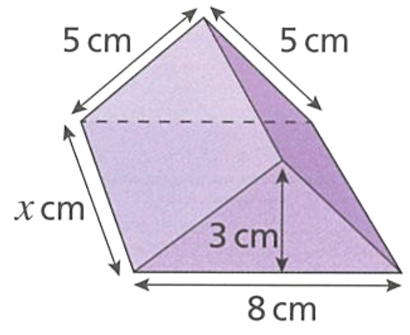
- This prism has surface area 222 cm². Determine the value of $x$.

$$\left(\frac{3×8}{2}\right)×2+5x+5x+8x=222$$
$$18x=198$$
$x=11$ cm

Surface Area of Closed Cylinders

- Net of a Cylinder
A cylinder's net has two circles and one rectangle.
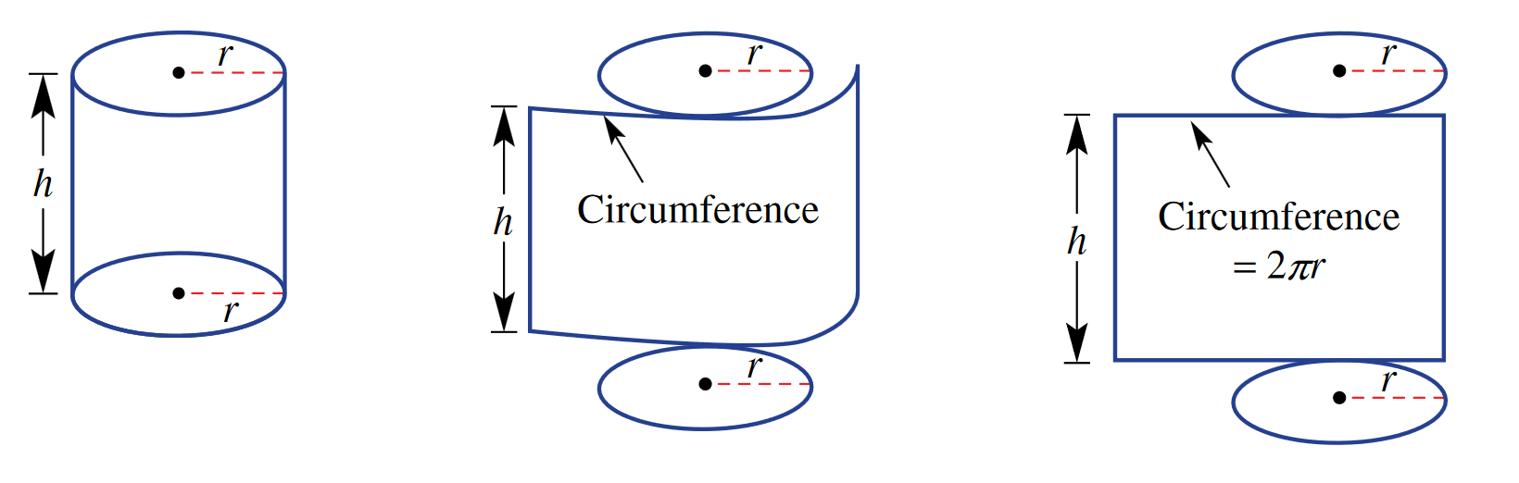

- Surface Area of a Cylinder
Calculate the surface area of these cylinders by adding the areas of each face.
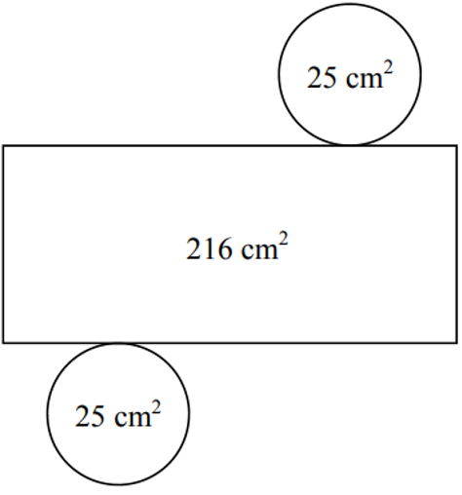 | 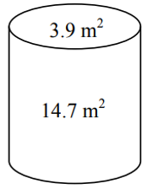 | 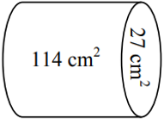
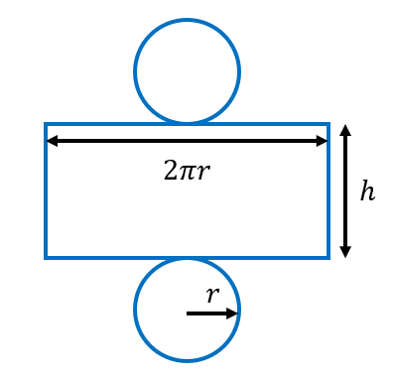
A cylinder is made up of ………… faces.
The top and bottom are circles, with area ………………
The curved part can be unrolled into a rectangle,
with length ………… and width ………………

So the total surface area is $A=$ ……………… $+$ ………………

- Surface Area of a Closed Cylinder
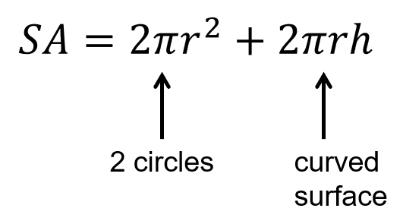

- Example Calculate surface area of a cylinder
Calculate the surface area of the cylinder, rounded to 2 decimal places.
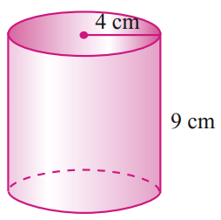  $A=2πr^{2}+2πrh$  $=2π{\left(4\right)}^{2}+2π\left(4\right)\left(9\right)$  $=326.73 {cm}^{2}$ | $2πr^{2}$ represents the ……………………………  $2πrh$ represents the ……………………………

- Guided Practice
Calculate the surface area of these cylinders.
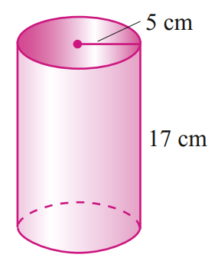  $A=2πr^{2}+2πrh$  $=$  $=$  691.15 cm² | 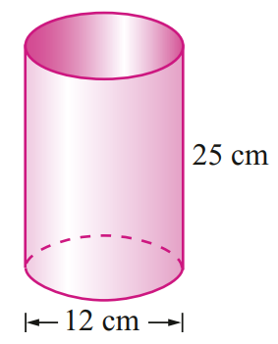  1168.67 cm²

- Key Ideas
- A cylinder is made up of two ………………… and a single ……………………………
- The rectangle’s dimensions are the height of the cylinder and the ……………………… of the circles that make up the bottom and top.

Foundation
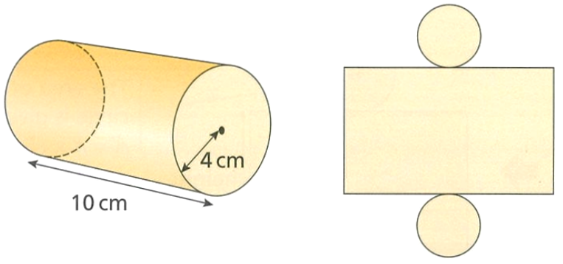
- Consider the cylinder and net to the right.
  - Label the net with correct lengths.
  - Calculate the area of:
    - The two circles.
Answer in exact form.

$2π{\left(4\right)}^{2}=32π$
    - The rectangle. Answer in exact form.

$$2π\left(4\right)\left(10\right)=80π$$
    - Hence find the surface area of the cylinder to 1 d.p.
351.9 cm²
- Find the surface area of these cylinders. Round your answer to 1 decimal place.
$A=2πr^{2}+2πrh$  $=$ …………………  $=$ …………………  2563.5 mm² | $A=$ …………………  $=$ …………………  $=$ …………………  150.8 cm² | 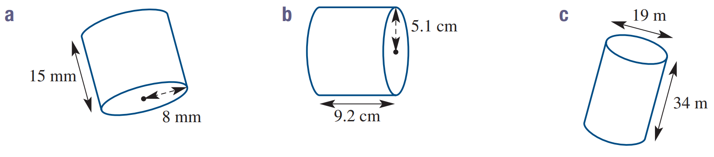  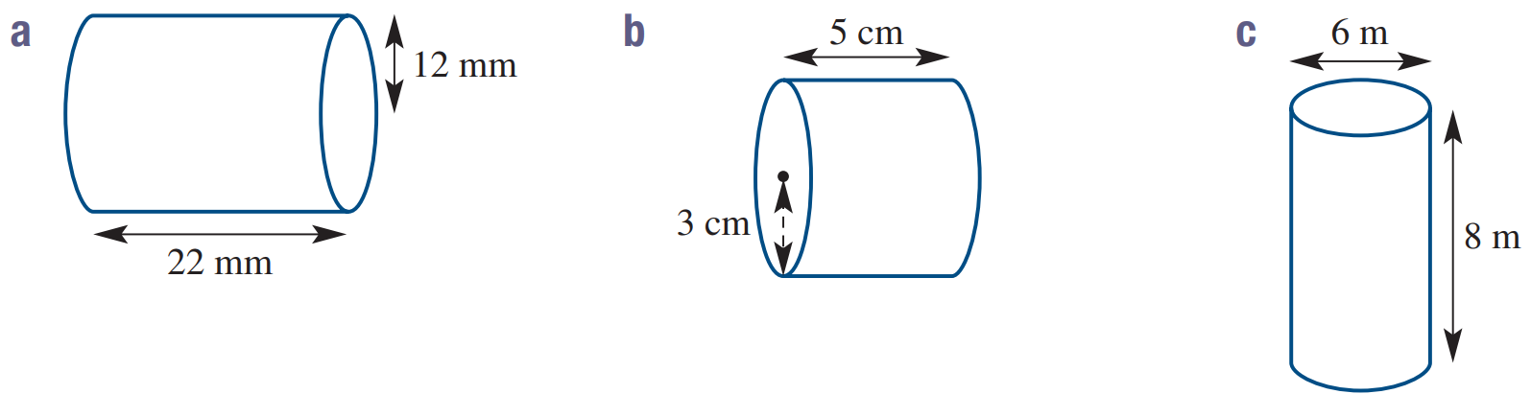  $A=$ …………………  $=$ …………………  $=$ …………………  458.2 cm²
1156.1 mm² | 207.3 cm² | 2596.5 cm²

Development
- Work out the surface area of each cylinder. Answer in exact from in terms of $π$.
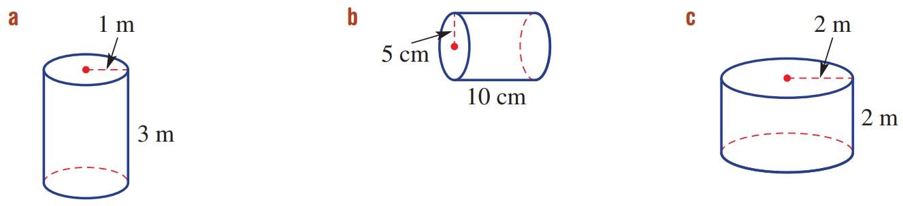  8π m² | 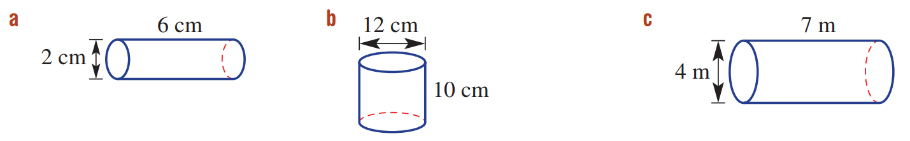  14π cm² | 192π cm²
16π m² | 150π cm² | 36π m²

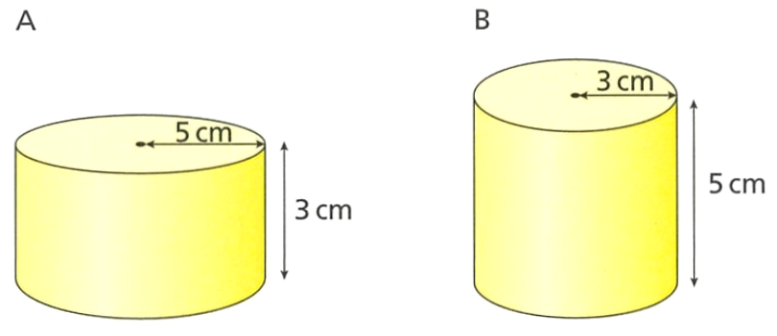
- Which shape has the larger surface area? Justify your answer.

A: 80π cm²
B: 48π cm²
A has larger surface area.
- A cylinder has a radius of 12 cm and a height of 20 cm.
  - Determine the surface area of the cylinder to 1 d.p.
2412.7 cm²
  - The height of the cylinder is increased by 10%.
Work out the new total surface area of the cylinder.

2563.5 cm²
  - Work out the percentage increase in the total surface area.

6.25% increase
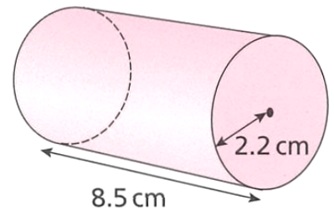
- Express the curved surface area of this cylinder as a percentage of the total surface area.
Give your answer to 2 decimal places.

Curved: $2πrh=$ 117.5 cm²
Total = 147.9 cm²
Percentage = 79.44%

- The radius of a circle is 6 cm. Calculate the area of the circle.  Leave your answer in terms of $π$  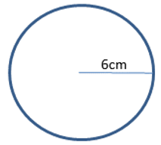  $36π$ cm² | 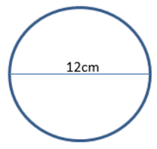  - Shown is a face of a cylinder with a height of 10 cm. Calculate the exact surface area of the cylinder.  192$π$ cm²
- The circumference of a circle shown is $7π$ cm. Calculate the area of the shaded region in terms of $π$.  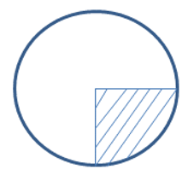  $$C=2πr$$  $$7π=2πr$$  $r=3.5$ cm  $$A=\frac{π{\left(3.5\right)}^{2}}{4}=\frac{49}{16}π {cm}^{2}$$ | 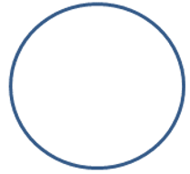  - The area of the circle is $16π$ cm². Find the circumference to 2 decimal places.  $$A=πr^{2}$$  $$16π=πr^{2}$$  $r=4$ cm  $C=2πr=8π$ cm

- A cylinder has radius 6 cm and height of $h$. The curved surface area of the cylinder is 754 cm² Work out the value of $h$.

$$2π\left(6\right)h=754$$
$h=20$ cm
- A cylinder has radius 4 m and height $h$. The total surface area of the cylinder is 128$π$ m².
Work out the value of $h$.
$$2π{\left(4\right)}^{2}+2π\left(4\right)\left(h\right)=128π$$
$$8πh=96π$$
$h=$ 12 m

Mastery
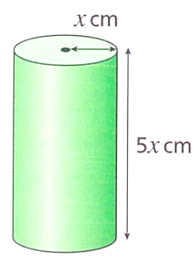
- This cylinder has a surface area of 972$π$ cm². Work out the value of $x$.

$$972π=2πx^{2}+2πx\left(5x\right)$$
$$x=9$$
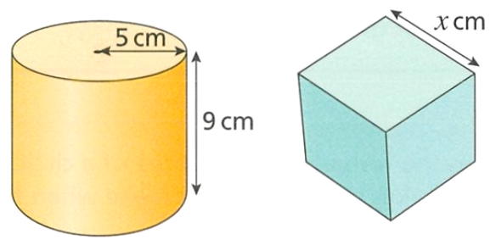
- The cylinder and cube have the same surface area. Work out the value of $x$ to 2 d.p.

SA of cylinder = $140π$ cm²
$6x^{2}=140π$ cm²
$x=8.56$ cm
- If you double the height of a cylinder, do you double its surface area?
Explain why.

No. Only the curved surface is doubled, and the circular ends stay the same, so the total is not doubled.
- Consider the cylinder below.
- Find the diameter of the cylinder to 2 d.p.  4.79 cm | - Calculate the volume of the cylinder.  18 cm²  9 cm  162 cm³
- The top surface of a cylinder with the same volume has area of 50 cm².  What is the height of the cylinder?  $$V=πr^{2}h$$  $$162=50h$$  $h=3.24$cm | - Calculate the surface area of the cylinder.  171 cm²
- Use Pythagoras’ Theorem $h^{2}=a^{2}+b^{2}$ to find unknown lengths and hence calculate the surface area of these solids. All units are in cm. Round your answer to 1 d.p.
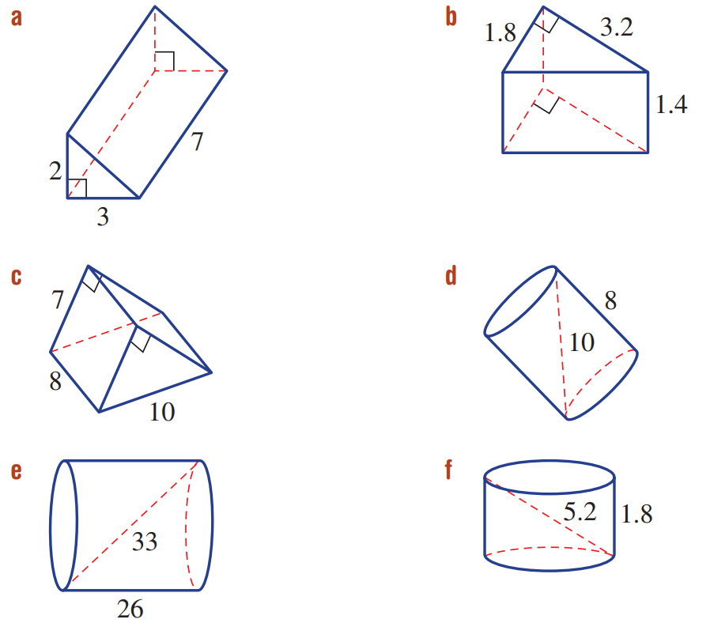  $r=3$ cm  $SA=207.4$ cm | $$r=10.1612…$$  $SA=2308.7$ cm² | $$r=2.43926…$$  $SA=65.0$cm²

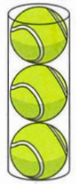
- Tennis balls are tightly packed in cylindrical cans which hold three balls.
The radius of a ball is 37 mm.
The curved surface is manufactured from thin aluminium which costs $4.80/m².
The top and bottom are made from stronger aluminium which costs $5.60/m².
At the Australian Open Tennis Championships, about 48 000 balls are used.
Find the cost of producing the cans to hold this number of balls.

Dimensions of can: $r=37$ mm, $h=222$ mm
Circular ends = $2π{\left(37\right)}^{2}=2738π$ mm²
Curved surface = $2π\left(37\right)\left(222\right)=16428π$ mm²
Cans needed = $48000÷3=16 000$
Strong aluminium needed = $2738π×16000=43 808 000π$ mm² ÷ 1000² = 43.808π m²
Thin aluminium needed = $16428π×16000=262 848 000π$mm² ÷ 1000² = 262.848π m²
Cost of thin aluminium = $43.808π×\$5.60=\$770.7105894…$
Cost of strong aluminium = $262.848π×\$4.80=\$3963.65446…$
Total cost = $4734.37

Check your answer using a faster method: Finding the cost of 1 can, then multiplying by 16 000.

Surface Area of Cylindrical Solids

- Surface Area of a Closed Cylinder

- Many questions will ask you to find a part of a cylinder.
- You need to decide how to adjust the formula:
  - Is there a full circular base, part of a base, or no base?
  - How much of the curved surface area remains?
- Is there a new flat surface where the cylinder was "cut"?

- Identify Formula for a part of a cylinder
Write an expression for the surface area of these solids; the radius is $r$ and height is $h$.
- Closed cylinder  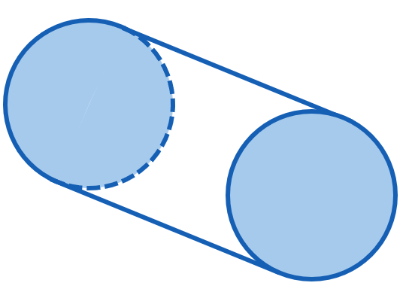  Two end circles:  Curved surface: | 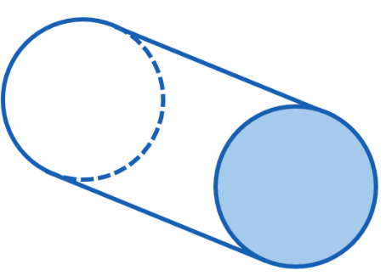  - Cylinder with  one open end  One end circle:  Curved surface: | - Cylinder open both ends  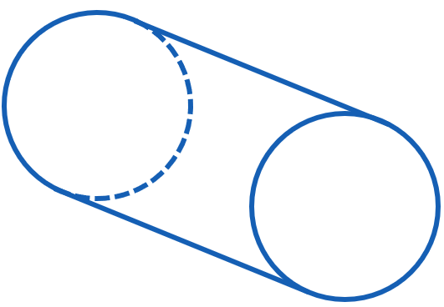  Curved surface:
- Closed half cylinder  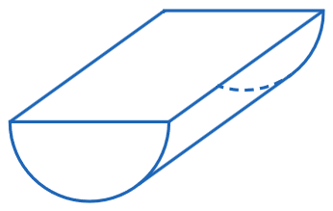  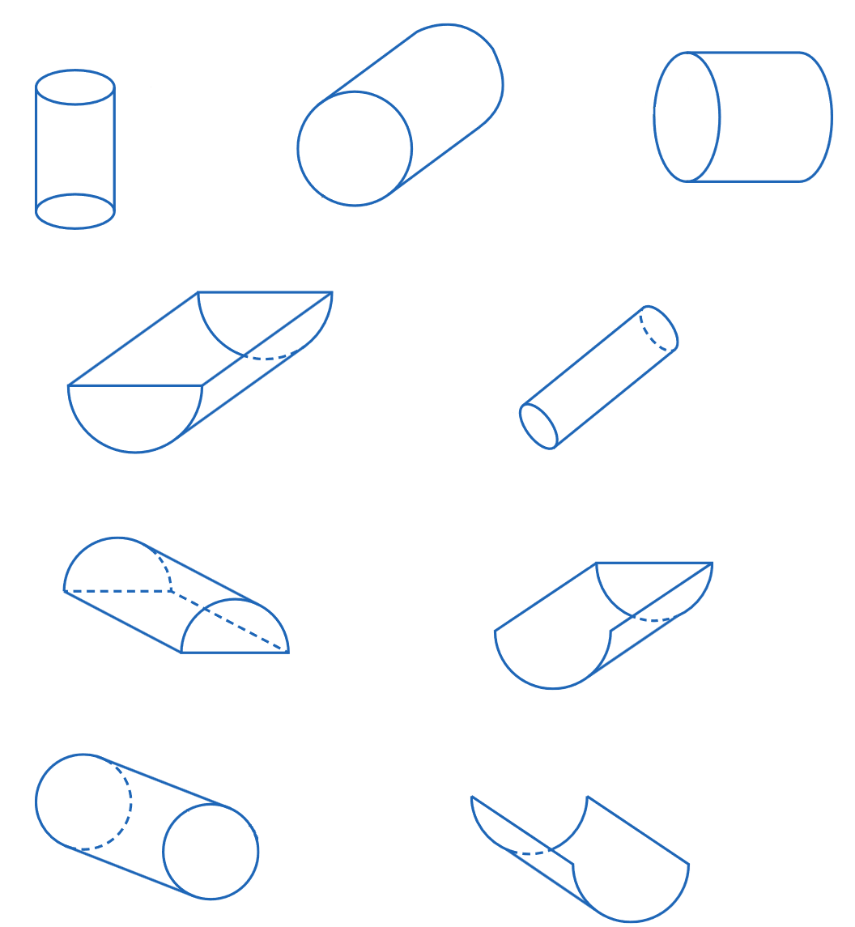  Two end semicircles:  Curved surface:  Top rectangle: | - Half cylinder with  open top  Two end semicircles:  Curved surface: | - Half cylinder with  open top, one end open  One end semicircle:  Curved surface:
- Example Calculate surface area of cylindrical solids
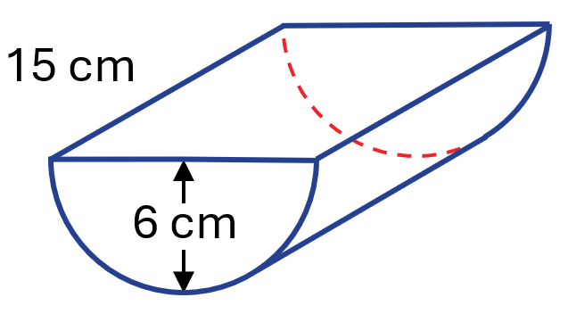
Calculate the surface area of this closed half cylinder, rounded to 2 decimal places.

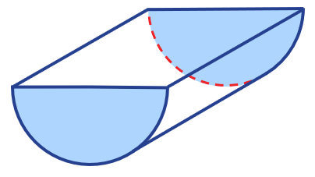  front and back semicircles | 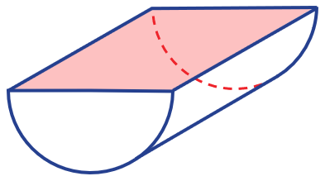  top rectangle | 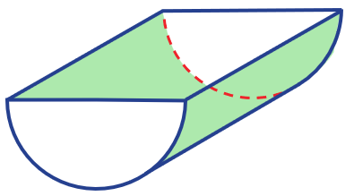  curved surface  (rectangle)
$$\left(\frac{1}{2}×π{\left(6\right)}^{2}\right)×2$$  $=113.0973…$ | $15×12$  $$=180$$ | $$\frac{1}{2}×2π\left(6\right)\left(15\right)$$  $=282.7433…$
Total surface area $=113.0972+180+282.7433$
$=575.84 cm^{2}$

- Guided Practice
Calculate the surface area of these solids.
Give intermediate answers to 4 d.p. and final answer to 2 d.p.
- Half-cylinder, open top  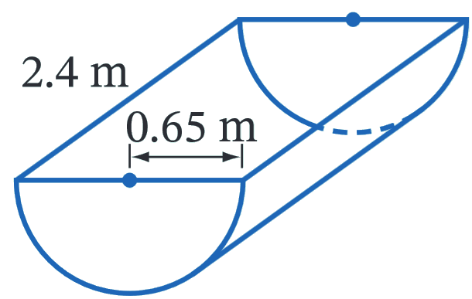  Front and back:  Curved side:  Total surface area:  6.23 m² | 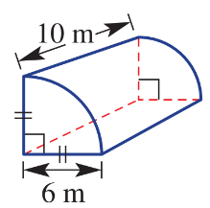  - Closed quarter-cylinder  Front and back:  Curved side:  Side rectangles:  Total surface area:  270.80 m²

Foundation
- Calculate the surface area of the following solids to the nearest whole number.
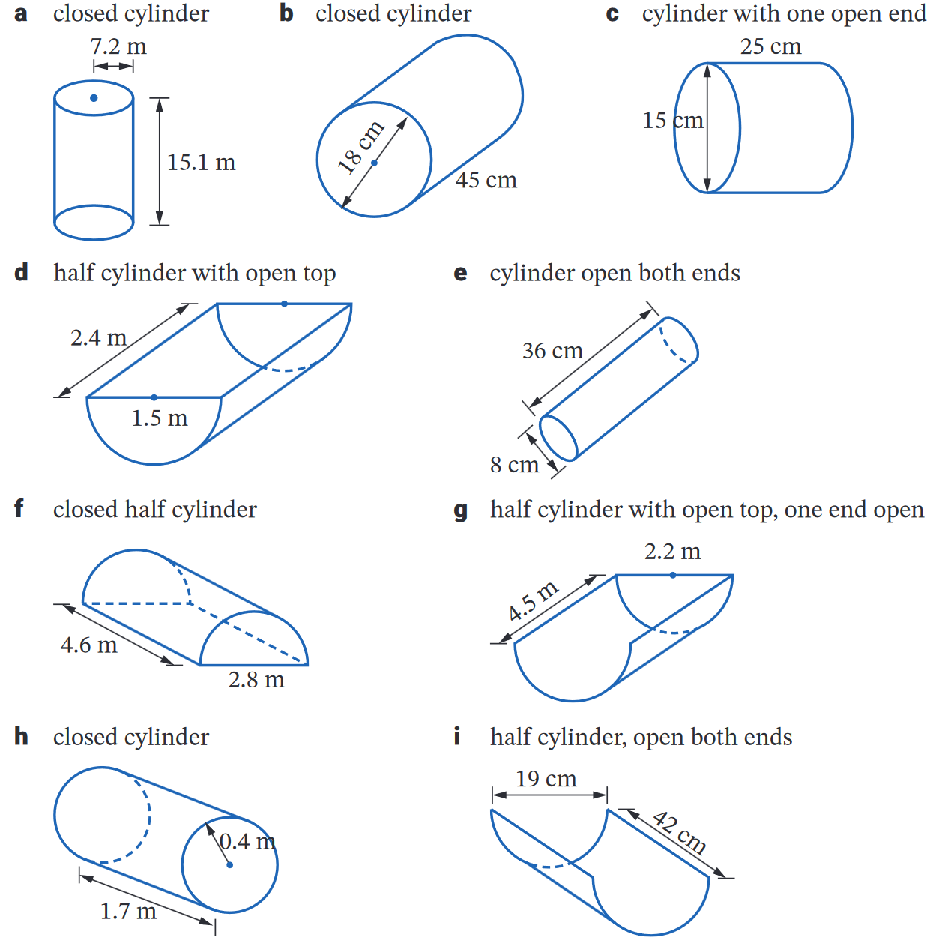  - Cylinder with  one open end  1355 cm² | - Half cylinder with  open top  7 cm² | - Closed half-cylinder  39 m²
- Cylinder open both ends  905 cm² | - Half cylinder with open top, one end open  17 m² | - Half-cylinder with  open top, open both ends  1253 cm²
- Closed quarter-cylinder  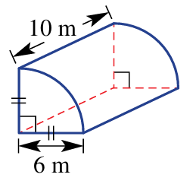  271 m² | - Half-cylinder with  open top  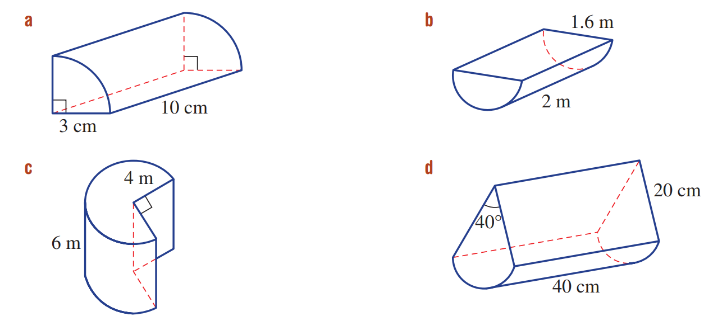  7 m² | - Closed half-cylinder  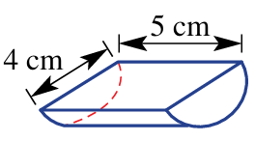  64 cm²

Development
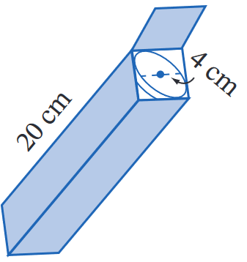
- Circular cracker biscuits of diameter 4 cm are packed in a cardboard box of length 20 cm.
How much cardboard would be saved if the biscuits were packed into a cylindrical box instead?

76 cm²
- 2018 HSC Standard 2 Band 4
A shade shelter is to be constructed in the shape of half a cylinder with open ends.
The diameter is 3.8 m and the length is 10 m.
The curved roof is to be made of plastic sheeting.
What area of plastic sheeting is required, to the nearest m²?
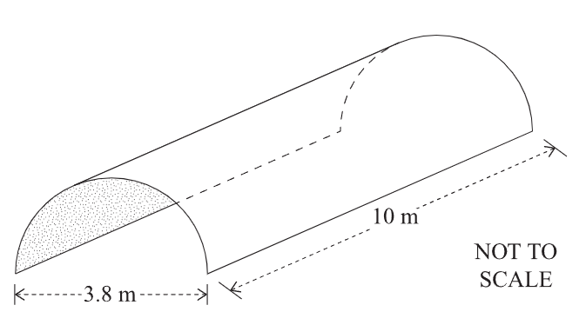

$$A=\frac{1}{2}\left(2πrh\right)$$
$$=2π\left(1.9\right)\left(10\right)$$
$=60$ m²
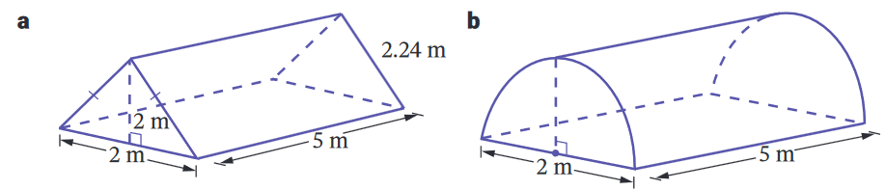
- Which tent has the greater surface area? (include the floors).

The triangular prism tent has 7.6 m² more surface area.
- Jessica is repainting a swimming pool in the shape of a cylinder 1.5 m tall and 6 m in diameter.
The inside of the pool is to be repainted, including the floor.
If a one-litre can of paint covers 9 m², find the number of cans needed.
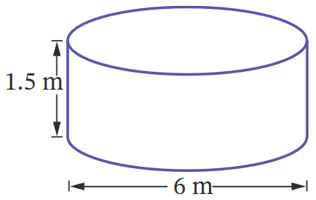

A = 56.5 m
6.3 L of paint required, so 7 cans to paint the pool.

Mastery
- The diagram shows a tent to be made in the shape of a half-cylinder.
The manufacturer knows that the flooring costs $18.50/m² and the top canvas costs $21/m².
How much would each tent cost to make? Answer to the nearest dollar.
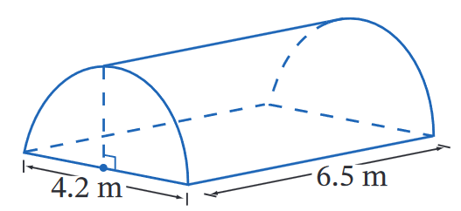

Floor: 27.3 m²
Surface Area: 56.7 m²
Cost = 27.3 × $18.50 + 56.7 × $21.75 = $1738
- Find the surface area of these closed partial cylinders. Answer in exact form.
(hint: arc-length is $l=$ $\frac{θ}{360}$ $×2πr$)
$$\left(60π+48\right) m^{2}$$ | $$\left(\frac{800π}{3}+1600\right) {cm}^{2}$$
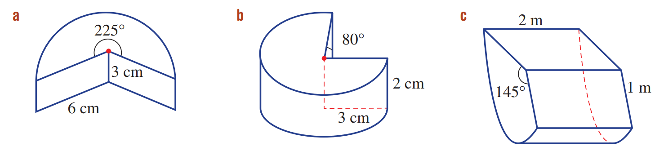  $$\left(\frac{135π}{2}+36\right) {cm}^{2}$$ | $$\left(\frac{70π}{3}+12\right) {cm}^{2}$$

Surface Area of Composite Prisms

- Example Calculate surface area of composite solids
Calculate the surface area of this solid, rounded to 2 decimal places.
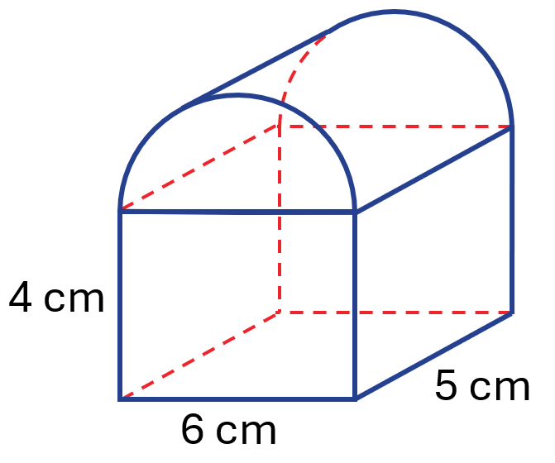

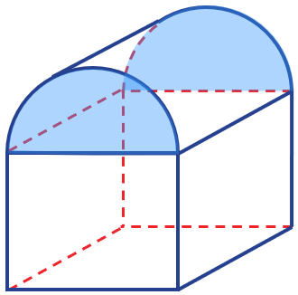  base  semicircles | 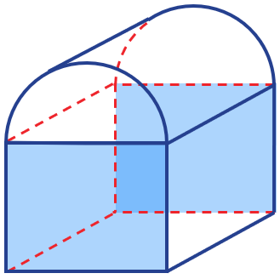  base  rectangles | 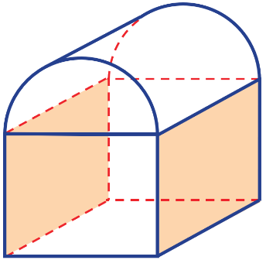  side  rectangles | 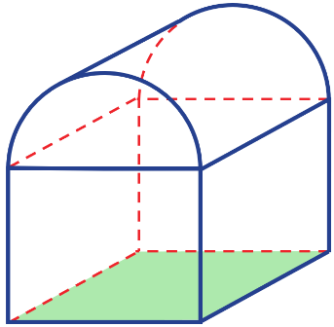  bottom rectangle | 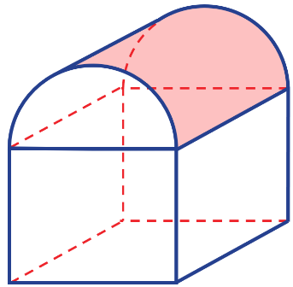  top surface (rectangle)
$$\left(\frac{1}{2}×π{\left(3\right)}^{2}\right)×2$$  $=28.2743…$ | $\left(4×6\right)×2$  $=48$ | $\left(4×5\right)×2$  $=40$ | $6×5$  $=30$ | $$\frac{1}{2}×2π\left(3\right)\left(5\right)$$  $$=47.1238…$$
Total surface area $=28.2743+48+40+30+47.1238$
$=193.40 {cm}^{2}$

- Guided Practice
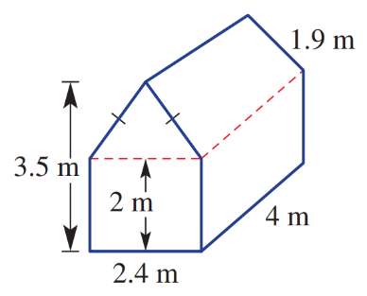
Calculate the surface area of this composite solid.
Give final answer to the nearest whole.

base triangles | base rectangles | side rectangles | top rectangles | bottom rectangle
Total surface area $=$

54 m²

Foundation
- Find the surface area of these solids. Round to 2 d.p.
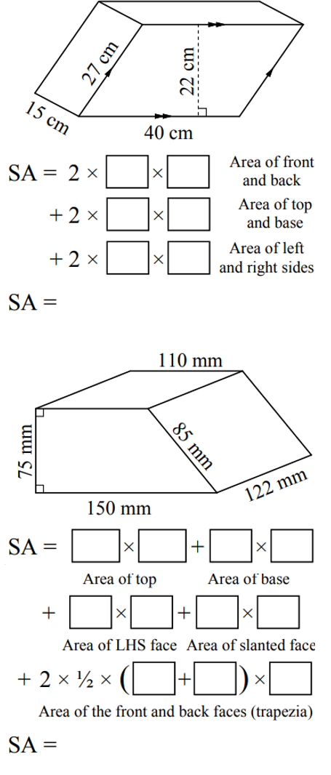  3770 cm² | 70 740 mm² | 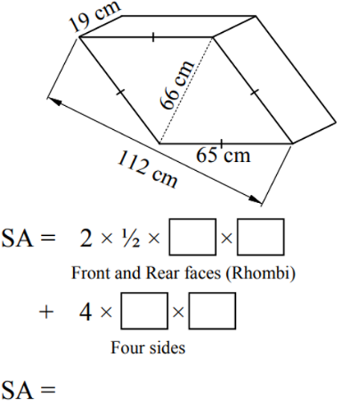  12 332 cm²

- Find the surface area of these solids.
Set your working out neatly to show that you have considered every face of the solid.
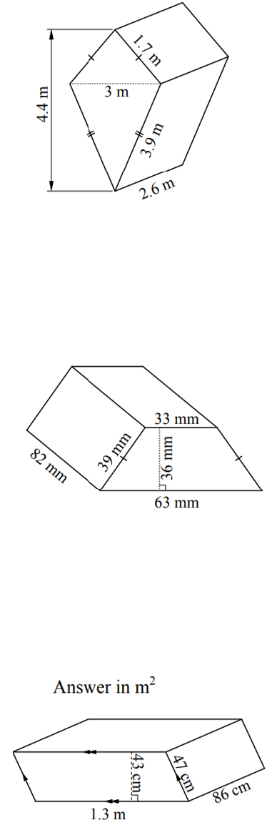  $$Front \& Back:\left(\frac{3×4.4}{2}\right)×2$$  $$Top two:\left(1.7×2.6\right)×2$$  $$Bottom two:\left(3.9×2.6\right)×2$$  Total: 42.32 m² | $$Front \& Back:\left(\frac{36}{2}\left(33+63\right)\right)×2$$  $$Left \& Right:\left(39×82\right)×2$$  $$Top:33×82$$  $$Bottom:63×82$$  Total: 17 724 mm² | $$Front \& Back:\left(1.3×0.43\right)×2$$  $$Left \& Right:\left(1.3×0.86\right)×2$$  $$Top \& Bottom:\left(0.47×0.86\right)×2$$  Total: 4.1624 m²

Development
- The floor, sides and roof of this tent are made from canvas at a cost of $5 per square metre. The tent’s dimensions are shown in the diagram. What is the cost of the canvas for the tent?
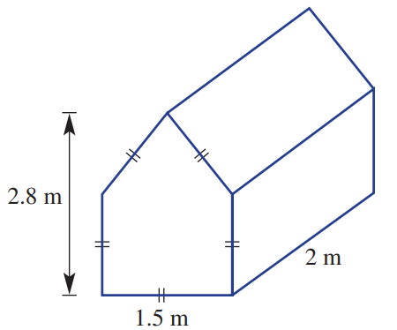

Surface area = 21.45 m²
Cost: $42.90
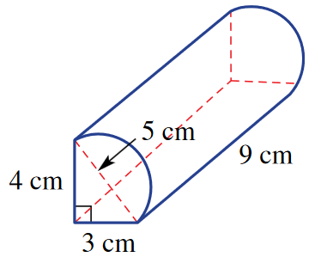
- Find the surface area of this composite prism to 2 d.p.

Front & back: $2$ $\left(\frac{4×3}{2}+\frac{π{\left(2.5\right)}^{2}}{2}\right)$
Left: $4×9$
Bottom: $3×9$
Right: $\frac{2π\left(2.5\right)(9)}{2}$
Total: 165.32 cm²
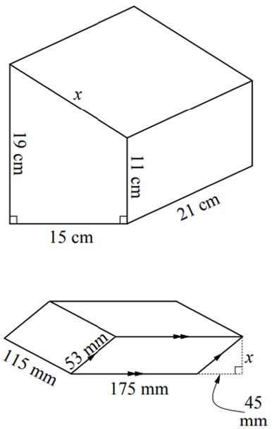
- Find the surface area of these solids.
First calculate the missing length using Pythagoras’ Theorem.
$x=17$ cm  Front & Back $\frac{15}{2}$ $\left(19+11\right)×2$  Left: $15×19$  Right: $11×21$  Top: $17×21$  Bottom: $15×21$  $SA=1752$ cm² | $x=28$ mm  Front & Back $(175×28)×2$  Left & Right: $\left(115×53\right)×2$  Top & Bottom: $\left(115×175\right)×2$  $SA=62 240$ mm²

Mastery
- The formula for calculating any solid with uniform cross-section is:
Surface Area of any Solid with
Uniform Cross-Section
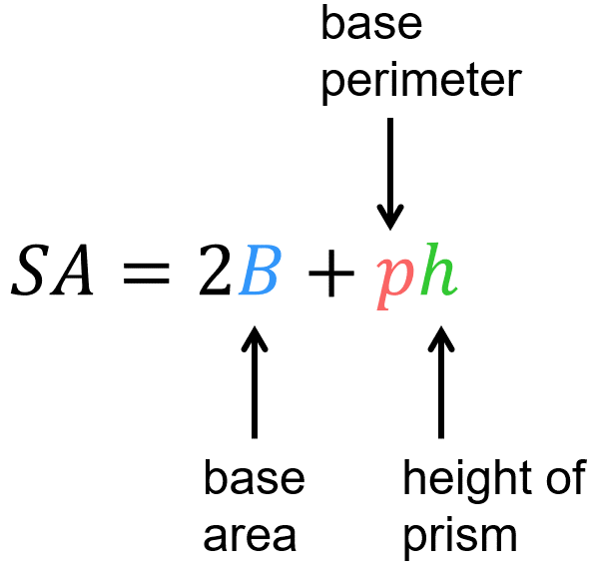
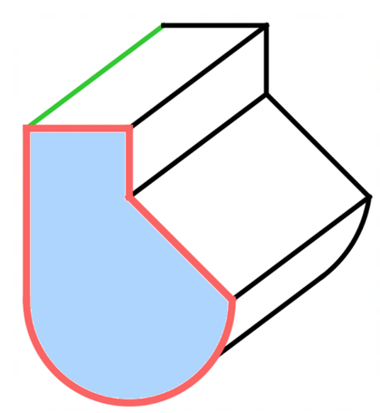

Calculate the surface area of these solids using the formula. Answer to 1 d.p. where needed.
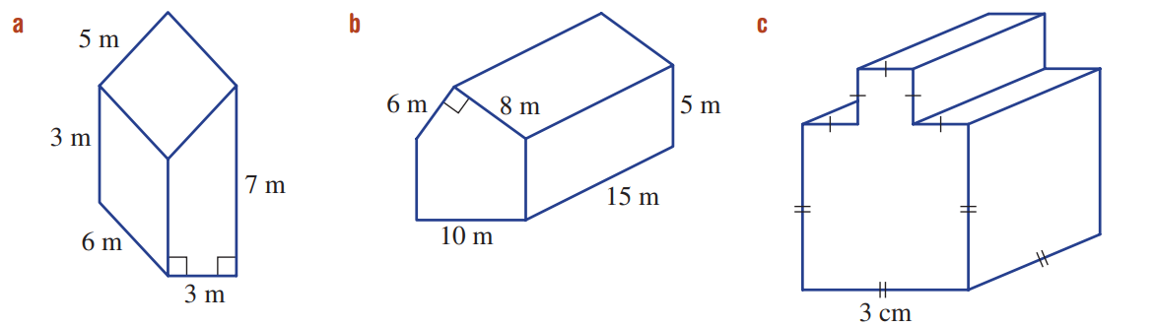  138 m² | 658 m²
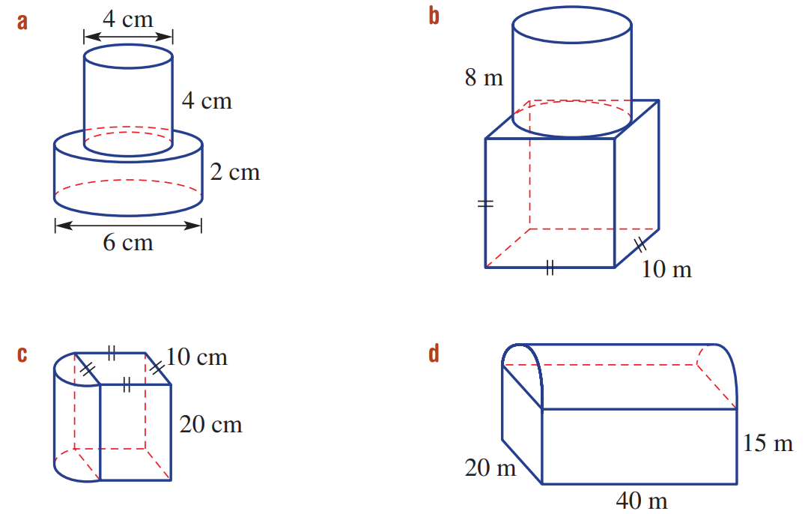  4170.8 m² | 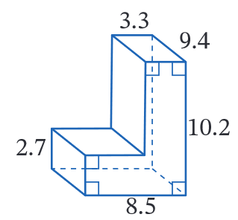  447.0 cm²
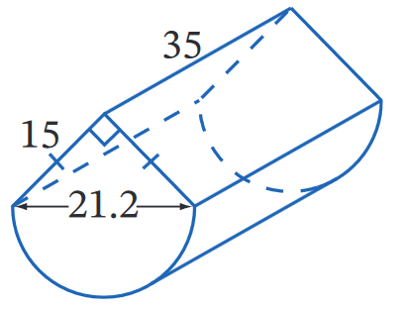  2793.5 cm² | 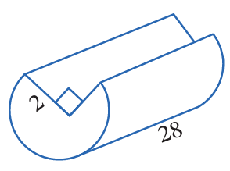  394.7 cm²
- 2020 HSC Standard 2 Band 4
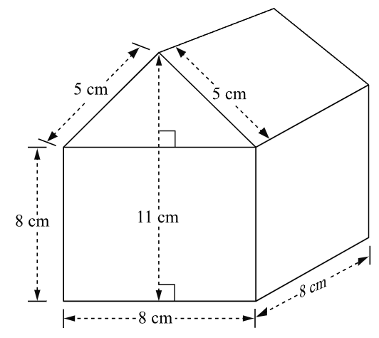
Calculate the surface area of the composite solid.

424 cm²
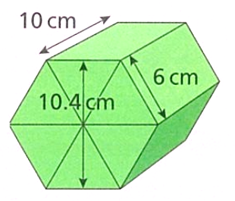
- Amina cuts a regular hexagonal prism into six, identical triangular prisms.
Work out the surface area of each triangular prism rounded to 1 decimal place.

The triangular faces are equilateral.
Area of triangles: $\frac{5.2×6}{2}$ $×2$
Area of rectangular faces: $\left(6×10\right)×3$
Total SA: $211.2$ cm²
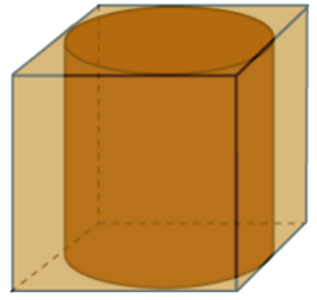
- A cube with surface area 216 square centimetres has a cylinder perfectly enclosed inside.
What is the surface area of the cylinder? Answer correct to 2 decimal places.

$$Find cube side length: 6x^{2}=216$$
$x=6$ cm
$SA of cylinder=2π{\left(3\right)}^{2}+2π\left(3\right)\left(6\right)=169.65$ cm²

Surface Area of Prism Combinations

- Example Calculate surface area of composite solids
Calculate the surface area of this solid, rounded to 1 decimal place.
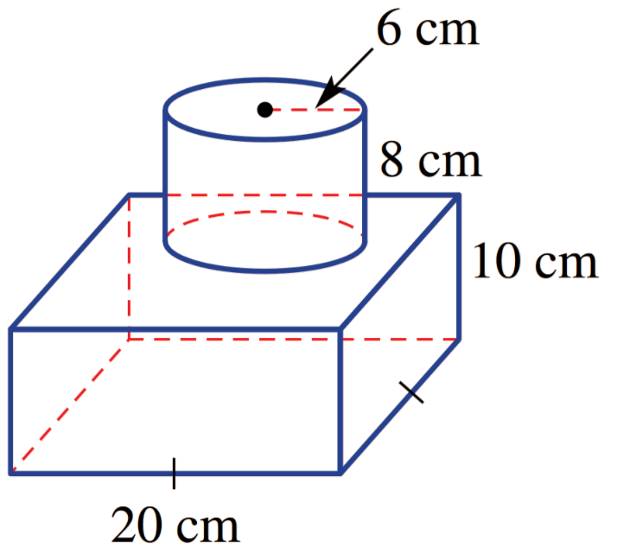

bottom square | 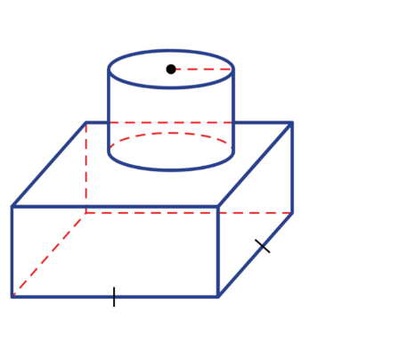  side rectangles | top square  – circle | curved surface  (rectangle) | 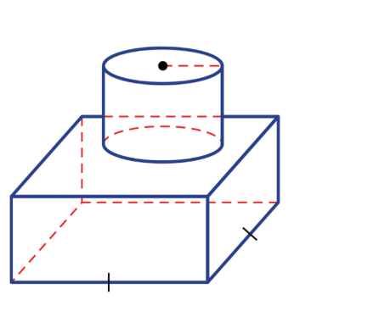  top circle
$20×20$  $=400$ | $\left(10×20\right)×4$  $=800$ | $$20×20-π{\left(6\right)}^{2}$$  $=286.90266…$ | $$2π\left(6\right)\left(8\right)$$  $$=301.59228…$$ | $π{\left(6\right)}^{2}$  $$=113.09733…$$
Total surface area $=1901.6 cm2$

- Guided Practice
- Show that the surface area of this composite prism is 101.7 m².
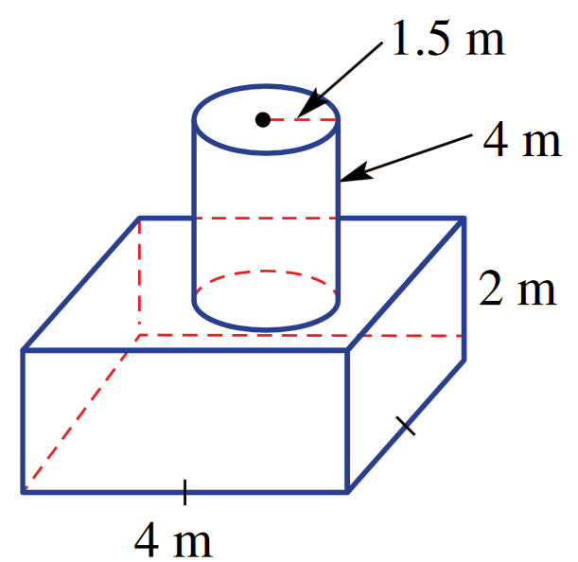

- Show that the surface area of this composite prism is 496 m².
Note that the base is not a square.
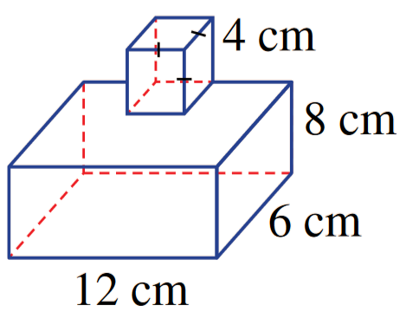

Foundation
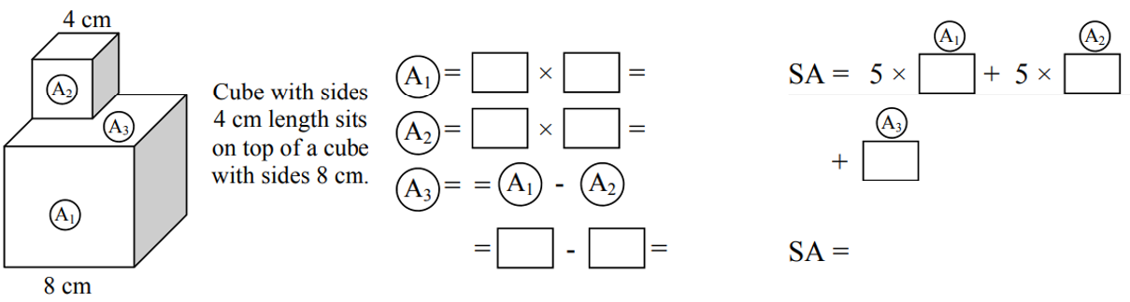
- Find the surface area of the cube.

448 cm²
- Find the surface area of these composite solids. Round to 1 d.p. where appropriate.
144.5 cm² | 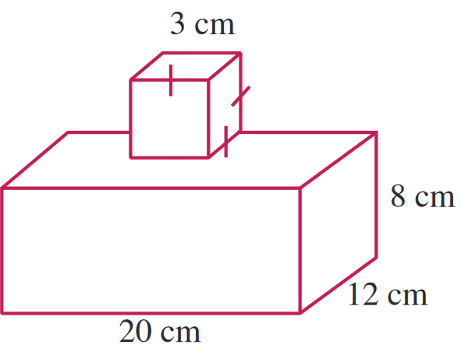  1028 cm²
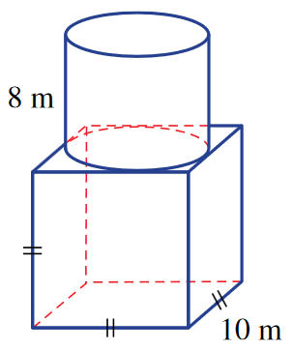  851.3 m² | - All measurements in cm.  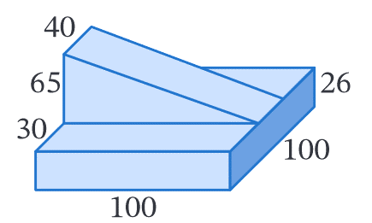  40 270 cm²
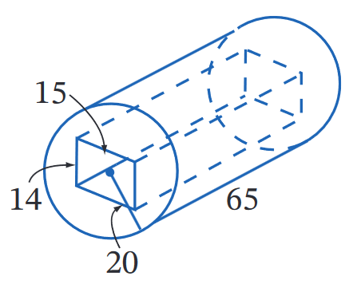  - All measurements in cm.  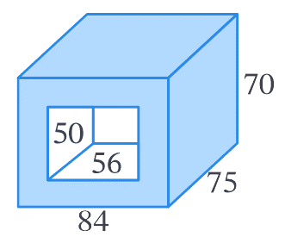  14 031.4 cm² | - All measurements in cm.  45 160 cm²

- A log with diameter 60 cm is 3 m in length. Its hollow centre is 20 cm in diameter. Find the surface area of the log in cm², including the ends and the inside, correct to 1 decimal place.
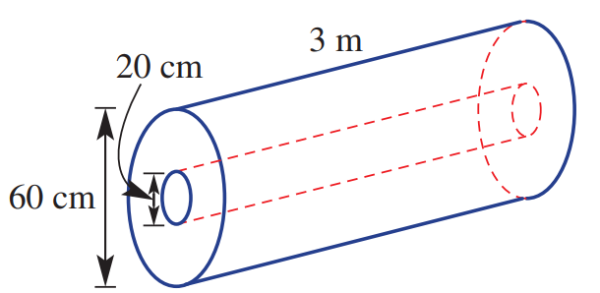

Circular ends: $\left[π\left({30}^{2}\right)-π\left({10}^{2}\right)\right]×2$
Outside: $2π\left(30\right)\left(300\right)$
Inside: $2π\left(10\right)\left(300\right)$
Total: 80 424.8 cm²

